Using the Website

I Logging into the Website

II. Downloading Transcribed documents from the Website

III Search files on the Website

IV Sending files for transcription from your computer

I Logging into the website
- Type the following URL in Internet Explorer address bar and click the ‘Go’ button
URL : http://accuratetranscriptions.com/

- Enter your User ID and Password and click the ‘Login’ button. The User ID and Password for ___________are as follows

User ID: Password:
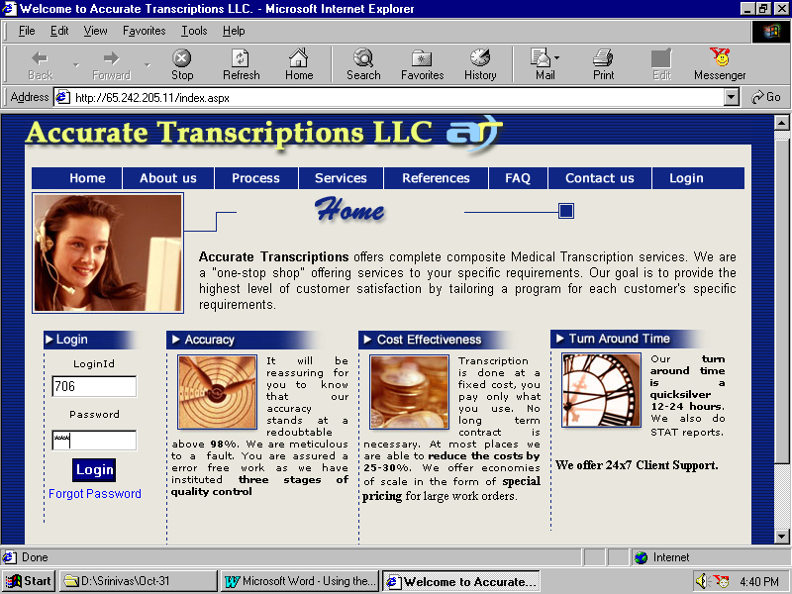

3. You will be shown the following screen
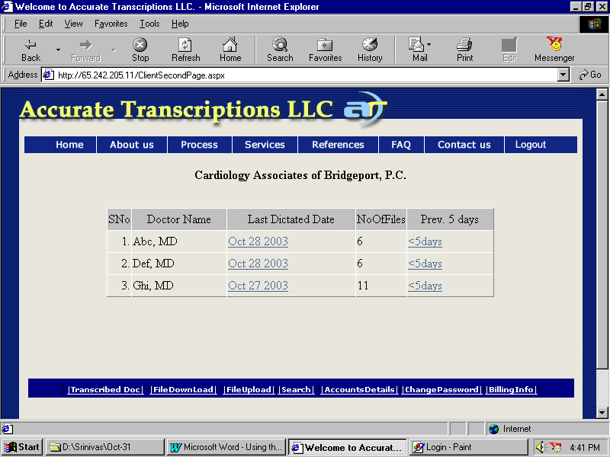

Fig. 2

This screen will display the list of doctors from the group along with a link to the files of the last dictated date and a link to list of dictations for previous 5 dictated dates.

When clicked on the last date of dictation, it the displays the following screen which will have the details of the patients on the selected date.

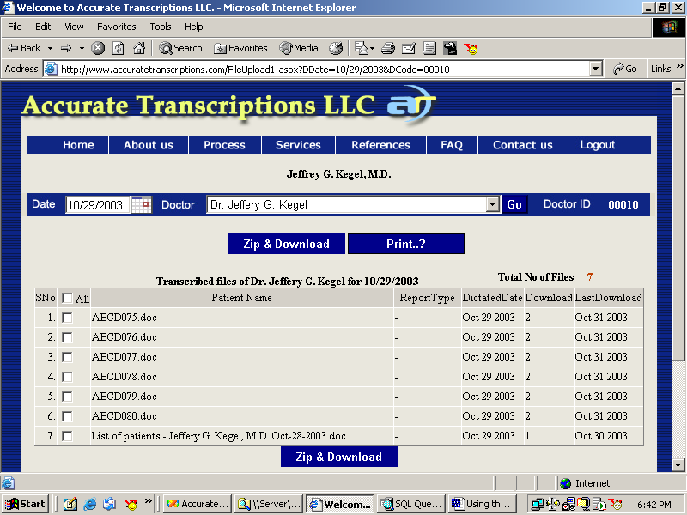

II Downloading And Printing the Transcribed documents from the website
- Ensure that your computer is connected to the internet

- Login into the website using Procedure I above.

- For ‘Downloading All Files’ files listed select the ‘All’ check box and click ‘Zip & Download’ button.

- Select the path where you want to download and click ‘Ok’.

- If clicked on the ‘5 Days’ link on the earlier screen the following screen is shown.

This displays the links of the dictated dates in the descending order along with the no. of files on the corresponding date. On selecting the required date it displays the previous screen which will enable the user to download the required files.

The user can use ‘Prev’ or ‘Next’ links on this screen to get the next set of 5 dictated dates.

The selection can be changed by selecting the doctor name from the drop down list and click ‘Go’.

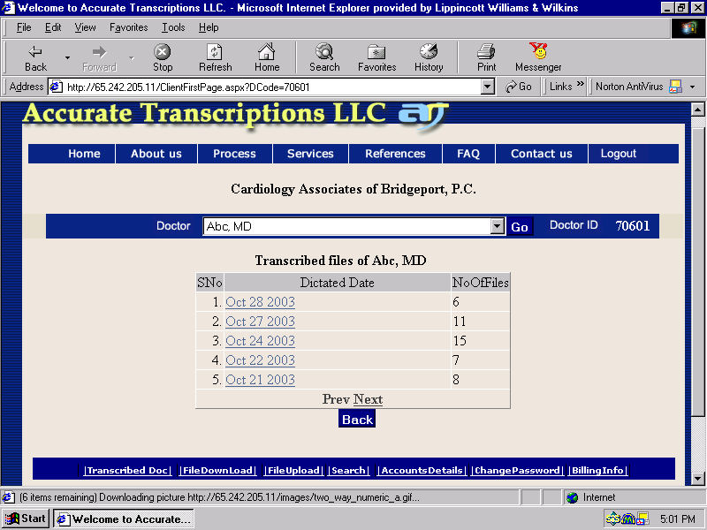
The selection of print button will navigate to the printing page. And there we can select the files and press print it will print the selected transcribed files through the default printer.
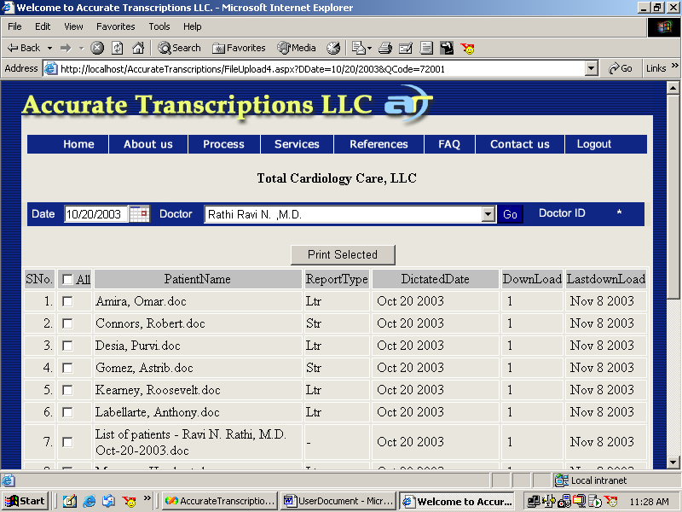

III Search files on the Website

Click the ‘Search’ button at the bottom of the page, which will display the below page.
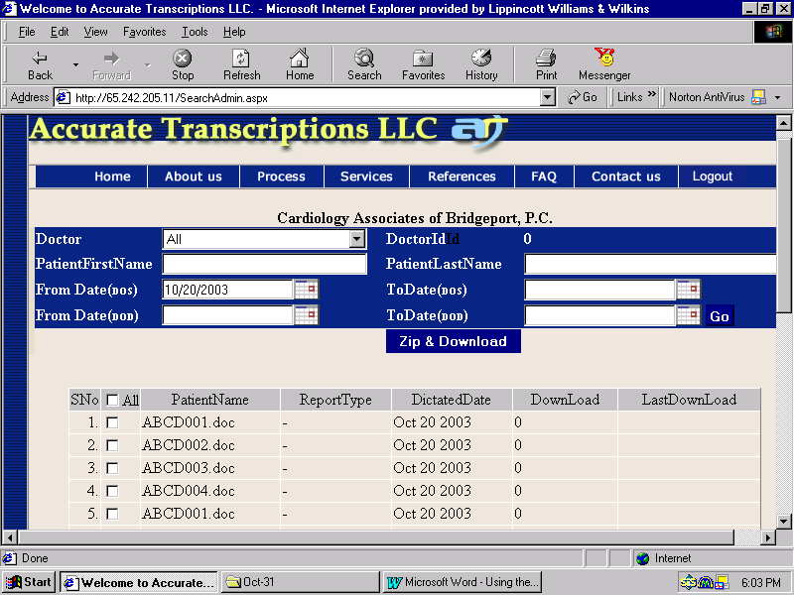

‘Search’ can be done doctor wise or on all the doctors of the group. Patient’s first name or last name can be mentioned. The search can be on any selected range of DOS (Date of service) or/and selected range of DOD (Date of dictation)

Select the required criteria and click ‘Go’ to view the results.

Once searched the files can be downloaded by selecting the file(s) (using check boxes associated) and click ‘Zip & Download’.

IV Uploading files for transcription from your computer

- Ensure that all the Digital recorder files have been transferred to the computer and the computer is connected to the internet.

- Use procedure I outlined above to login into the website.

- Click the ‘Upload Files’ link on the fig. 2, which will display the screen shown below:
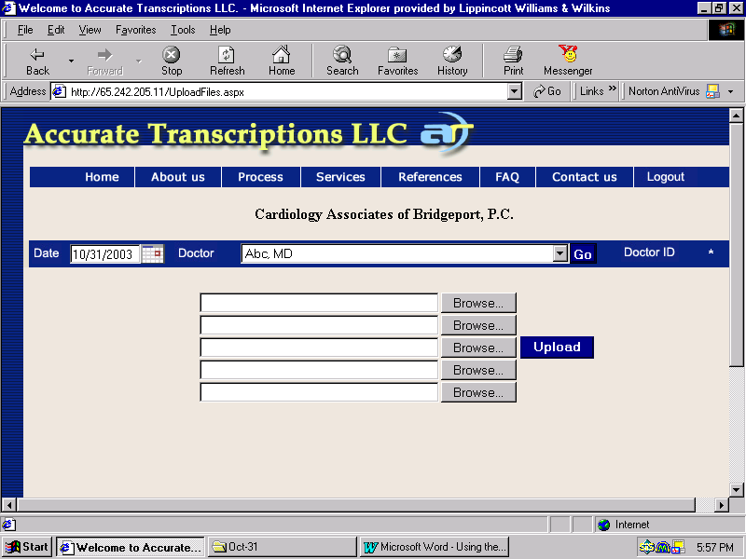

Select the date of the dictation and select the dictating doctor from the drop down list and click ‘Browse’ button to select the file to be uploaded. At a time the user can upload 5 files.

Upon selecting the files click ‘Upload’ button to send the files for transcription. Upon successful uploading you will receive a message an appropriate message.

